1.By Chatgpt
Create a professional promotional image of young travellers inside a modern airport terminal. Use blue and white brand colours, natural lighting and a landscape layout. Do not include airline logos or text.

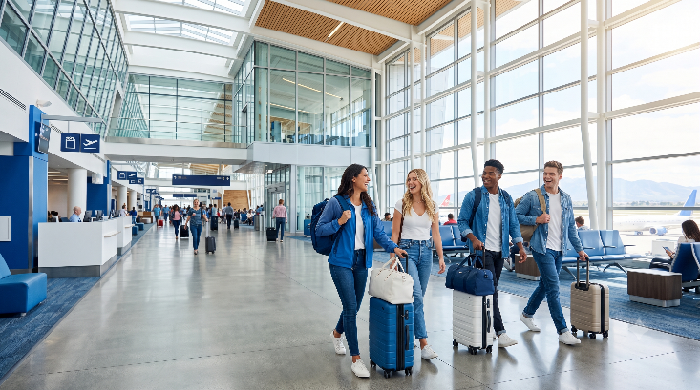

2.By Perplexcity
Create a professional promotional image of young travellers inside a modern airport terminal. Use blue and white brand colours, natural lighting and a landscape layout. Do not include airline logos or text.
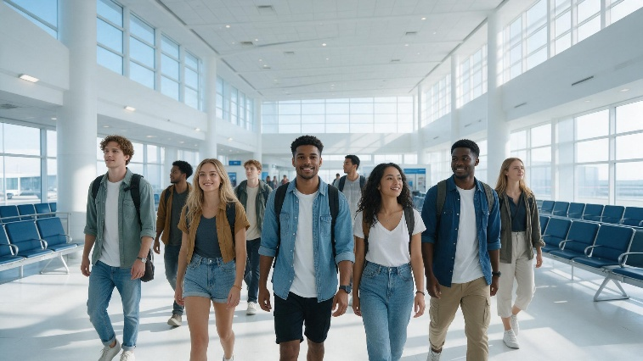

3.by Recraft
Create a professional promotional image of young travellers inside a modern airport terminal. Use blue and white brand colours, natural lighting and a landscape layout. Do not include airline logos or text.

4. By Ideogram
Create a professional promotional image of young travellers inside a modern airport terminal. Use blue and white brand colours, natural lighting and a landscape layout. Do not include airline logos or text.

5.By FireFly
Create a professional promotional image of young travellers inside a modern airport terminal. Use blue and white brand colours, natural lighting and a landscape layout. Do not include airline logos or text.
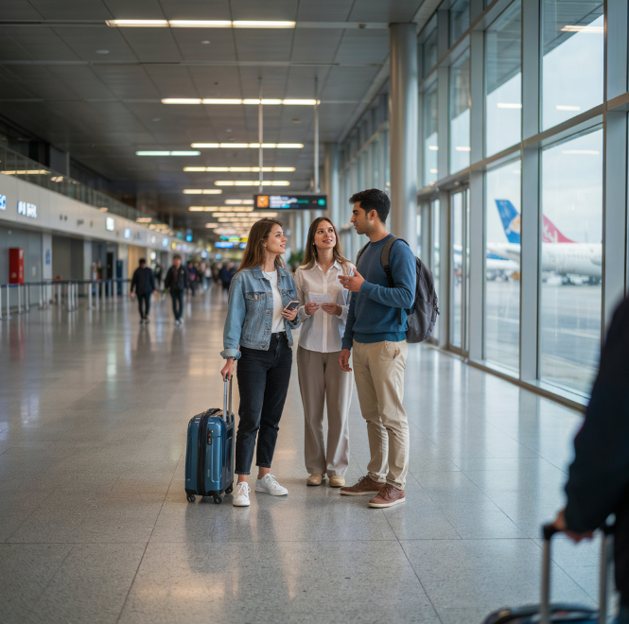

6.By Leonardo Ai
Create a professional promotional image of young travellers inside a modern airport terminal. Use blue and white brand colours, natural lighting and a landscape layout. Do not include airline logos or text.

7.By Gemini
Create a professional promotional image of young travelers inside a modern airport terminal. Use blue and white brand colors, natural lighting and landscape layout. Do not include airline logos or text.

